PgCert Academic Practice in Art, Design and Communication
Action Research Project Ethical Enquiry Form

Participant name: Ingrid Plum

Cohort: 3

Tutor name [delete as appropriate]: Liz Bunting / Rachel Marsden

- What is your research question?

How do we support student voices to be heard from marginalised groups without increasing their vulnerability via visibility?

The aim of the Experimental Choir workshops is to develop extra-curricular spaces for non binary, trans and female students to feel their voices are equally heard. We will workshop using the voice to perform scores by composers who identify as non-binary, trans and female, building confidence in using the voice that will impact positively on their creative work, in creating more potential for them to utilise their voice in sound works, and in using their voice in class discussions. The activities within the workshop will begin to build a lexicon for composers to encourage accessibility and inclusivity in score making through collaboratively designing a card deck of prompts for composers to consider.

As a non-binary member of staff I have undertaken activism within the department to build community between non binary, trans and female students across years and courses in the department. In the previous unit, Inclusive Practice, the visibility of activism, and of students and staff who identify as female, non binary or trans, was highlighted as both a potential pathway for community building and a potential for vulnerability. In this project I will be focusing on embedding visibility within the choice of composers and the visiting practitioner who will join us for one session.

- Who will be providing you with information to help you answer your question, and how will you approach and/or select them?
Students at UAL
Staff at UAL

I expect between 7 and 15 students and staff to participate in the workshop, with varying attendance for all sessions. Both staff and students will be part of the same choir workshops.

How will you approach and/or select from each category?

I will advertise the choir workshops via posters and emails aimed at students and staff within the Sound and Music Programme who have an interest in working with the voice, as well as emailing a mailout to students within the Sound and Music programme. There is no criteria of selection, the workshops are for both trained and untrained voices, and participants will be respondents to the posters and mailout rather than approached by me. I will inform them about the project and my research aims in the email, as well as at the start of each session. There will be 4 workshops in total, and I will go through the consent form at the start of each session to make sure all participants have completed it, so that if there are different participants for different sessions they will all have completed the form.

- What will you be asking participants to do?
As part of participating in the choir workshops participants will be asked to:

- Consent to their participation in the experimental choir being observed and/or documented via recordings, photos, and written documentation
- Consent to the production of a collaborative outcome with their input via participatory research, after exploring scores by composers participants will be asked to contribute suggestions for prompts that will form a card deck for composers to conder aspects of inclusivity and accessibility in composition. Participants will be asked to consent or opt out of being credited for their contributions, and asked what name they want to be credited, these will appear on one of the cards in the deck, a ‘credits card’.

Project plan:

Workshop 1: vocal exercises, sonic meditations, workshopping score by Annea Lockwood, discussion and suggestions for prompts

Workshop 2: vocal exercises, sonic meditations, Visiting Practitioner workshop on collaborative score making, discussion and suggestions for prompts

Workshop 3: vocal exercises, sonic meditations, workshopping score by Meredith Monk, discussion and suggestions for prompts

Workshop 4: vocal exercises, sonic meditations, workshopping score by Pauline Oliveros, reflective discussion on prompts for composers and written discussion on impact of workshops on the use of the voice

- How will you get informed consent from these participants?

I will ask students and staff to sign an online consent form which I will show via a QR code or link at the start of each workshop session, or via a form handed out for participants to sign. I will ask for their consent to use the results of our activities and discussions as part of my research, as well as the collaborative work on the outcome of building a lexicon for future use, which will take the form of a card deck of inclusive prompts for scoring accessible and inclusive sound works. I will also ask them to provide the name for credit for their IP as part of the collaborative outcome and an option to opt out of being crediting whilst still allowing their input into the activity to be used. If participants wish to remain anonymous, I will have an option for them to tick for this, and in writing about their input I will give them a reference that is anonymous such as participant C. Audio recordings and photography consent will be requested verbally on the day of the participants present on that day as well as in the online consent form, and if participants ask not to be included in this then photos with them in will not be used and they will not be recorded.

I will complete a participant information form which I will supply a link to for participants to read and will include this in the mailout to students before the workshops.

- What potential risks to the interests of participants do you foresee and what steps will you take to minimise those risks?

I will give a short health and safety introduction at the start of each workshop, ensuring participants know they should take breaks when needed, where the nearest facilities are and that they should only do what they feel physically and emotionally comfortable doing. Some participants will not have experience in working with the voice, and this may bring up issues around identity, being heard, and confidence in using the voice. To prepare for this, I will have a distress protocol in place. This will include suggesting participants can take a break outside of the workshop room when needed, that they can make a time to discuss their responses with me outside of the workshop and signposting for further resources on voice, identity, confidence in using the voice and counselling at UAL. There is a physical barrier to the workshop in the form of stairs as the lift doesn’t access the floor where the workshop room, is, this was the only space available in the department due to limitations in room booking this year, and participants will be warned about this by email ahead of time. The workshop room is new and an arts temp tech has been organised to meet participants in the office and lead them up to the space as people are not familiar with the location yet.

- What potential risks to yourself as the practitioner do you foresee and what steps will you take to minimise those risks?

I have learnt from the previous unit Inclusive Practice that I can put myself at risk through heightening visibility of myself as a non-binary member of staff. There have been a lot of staffing changes in the department creating a shifting landscape in which the same activities get a different response. I encountered barriers to the activities I planned from other members of staff, so this time I have approached this without highlighting marginalised aspects of myself or of the participants, in order to protect both myself and participants. This project doesn’t focus on trauma and should not be emotionally demanding. However, it is trauma informed, as it aims to increase inclusivity, confidence and community and so as this may indirectly connect to previous experiences the distress protocol detailed above will be in place.

I would like to have tutorials with my tutor during the weeks of running the workshops to check in re my wellbeing.

I will put several resources in place as part of the activity that will support myself and participants’ safety and wellbeing, including singing scores from a variety of artists who are from marginalised groups, therapeutic breathing and vocal exercises, and guided sonic meditation. These will be prefaced with the health and safety talk and acknowledgment that working with the voice can be exploratory and individuals should pace themselves to do what they feel comfortable doing. The works chosen and activities will have differentiation for people to participate in different ways and to different extents.

- Does your project involve children or vulnerable adults e.g. a person with a learning disability?

YES, it is likely that some participants will have learning difficulties.

If yes, describe the extra measures you will put in place to safeguard vulnerable participants:

Scores will be explained verbally as well as being available in printed form, large font size will be used, and participants will be able to take part through the use of their voice in the manner they choose. Differentiation and regular breaks will be provided as part of the sessions content.

- How will you store the information you gather from participants?

You will need to think about how you store the information you collect from/about them, especially if you have offered your participants anonymity. You should also consider how long you will retain it for.

- Will you separate personal identifiers (e.g. names, student numbers) from other information? How?

I will separate personal identifiers from participants names at the stage where I write up their responses.
- After your enquiry, which of your data sets will you retain, how long for, and for what purpose? How will they be stored?
Edited recordings and photos will be stored for up to 5 years, ensuring that anyone who has requested to remain anonymous retains anonymity and the credits are maintained where requested. I will retain consent forms which will be kept on an encrypted drive.
- Which of your data sets will you destroy? Why? How will you ensure its confidential disposal?
I will digitally delete digital photos that contain participants who requested anonymity.

I confirm my responsibility to deliver the project in accordance with the Code of Practice on Research Ethics of the University of the Arts London (the University). In signing this form I am also confirming that:

- The form is accurate to the best of my knowledge and belief.
- I understand and accept that the ethical propriety of this project may be monitored by the relevant College Research body and/or the University’s Research Ethics Sub-Committee.
Signed: 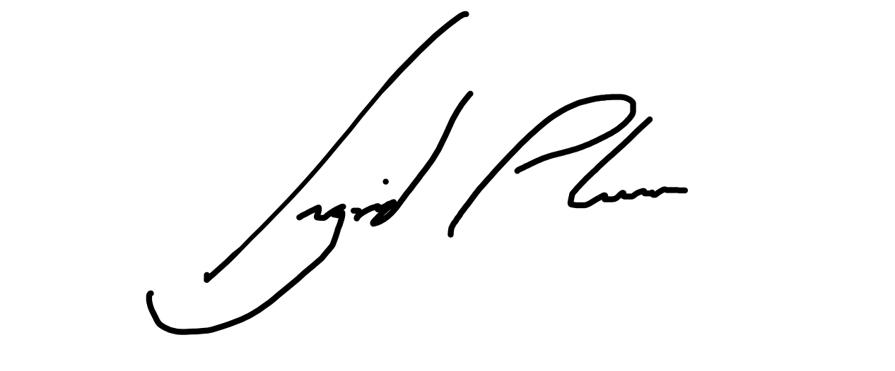____ Date: __30/10/23____
I support this project and have reviewed it with the participant:
Signed: ____________________________ Date: ____________

